Test case 1

Test Case 2

Test Case 3

Test Case 4 : Owning Organization :

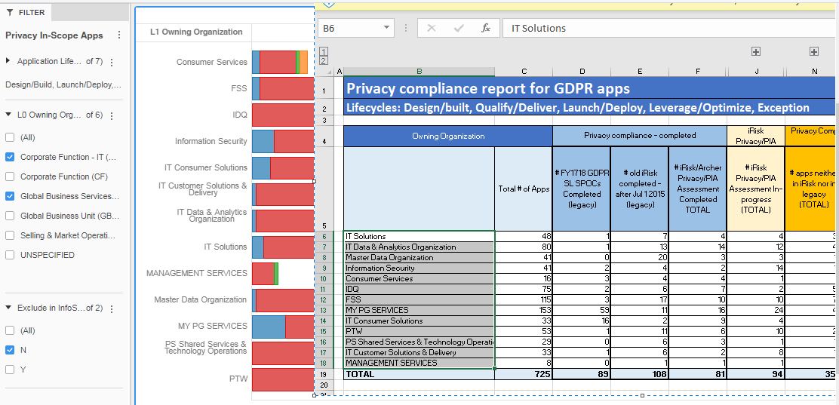

Test Case 4: Life Cycle Status ‘ Execution’ is not available in the main RITA cube as well.